Brandon Ytuarte
BUSA-695 Capstone
Capstone Project Wk-6: Final Report
Franklin University Spring 2026

Data Description
This data came from UC Irvine's Machine Learning Repository, which hosts and makes freely available for practice with different machine learning tasks. According to the UC Irvine page for this dataset, the data were collected from marketing campaigns by a Portuguese banking institution.
The data contains 41,188 rows and 21 columns with 8,213 missing values in only the ‘default’ column.
This data intentionally requires some preprocessing, often specific to the machine learning task the user plans to employ. For general analysis, the column names will need to be more specific, and missing values will need to be imputed with the column's mean, median, or deleted entirely.
I plan to analyze this data from the perspective of a banking marketing analyst, so customer segmentation using clustering algorithms will be important. To utilize clustering algorithms on this data, I will need to scale the data so that each column's values have equal effect on the algorithm, and to OneHot or Ordinal encode categorical variables so they can be processed numerically by the clustering algorithms.
Lastly, this data set is best for practicing machine learning tasks using classification algorithms, but the pre-processing will be largely the same before using these algorithms.

Business Rules UCI Bank Marketing Dataset:

Rule 1: Duration Implies Outcome
- For duration = 0, then y (now term_deposit_subscribed) = ‘no’ ( a call that never happened cannot result in a subscription)
- Also, once a call ends, y is known, so duration should not be used in realistic predictive models, only benchmarks.
Rule 2: No prior contact encoding
- If pdays (now dropped) = 999, then the client was never previously contacted in a prior campaign.
- This is a sentinel value, not a real number of days; it needs special handling (not treated as numeric).
Rule 3: pdays and previous are linked
- If pdays = 999, then previous_contacted should logically should logically be 0 (no prior contacts means no prior campaign contacts either)
Rule 4: poutcome reflects prior contact
- If pdays = 999 (never contacted before) then positive_campaign_result = ‘nonexistent’
- You can have a prior campaign outcome if there was no prior contact.
Rule 5: Missing values are encoded as ‘unknown’
- For categorical fields like (job, marital_status, education_level, default_status,
- has_home_loan, has_personal_loan) all missing data is encoded as unknown. These must be handled explicitly through (imputation, deletion, or treated as a separate class)
Rule 6: ‘divorced’ also covers widowed.
- marital_status = ‘divorced’ covers both divorced and widowed clients. These are not separate in the data.
Rule 7: The campaign includes the last contact
- campaign field counts all contacts, including the last one; it is never 0 for any record in the dataset.
Rule 8: Target Variable is binary
- term_deposit_subscribed has only two valid values: ‘yes’ or ‘no’. No unknowns exist for the output variable.

Data Dictionary:

- age: Customer age
- job: type of job the customer has
- marital_status: marital status of the customer
- education_level: Education level of the customer
- default_status: Does the customer have credit in default?
- has_housing_loan: Does the customer have a housing loan?
- has_personal_loan: Does the customer have a personal loan?
- communication_type: Customer contact communication type.
- last_contact_month: Last month, the customer was contacted.
- day_of_week: Last day of the week the customer was contacted.
- last_contact_duration_sec: Last contact duration, in seconds.
- campaign: number of contacts performed during this campaign and for this client.
- previous_contacted: Number of contacts performed before this campaign and for this client.
- Positive_campaign_result: Outcome of the previous marketing campaign.
- Euribor_3mo_rate: euribor 3-month rate - daily indicator.

- Output variable (desired target):
- term_deposit_subscribed - Has the client subscribed to a term deposit?

Exploratory Data Analysis

Missingness by Column:
The dataset has missing values labeled ‘unknown’, so we'll count them for each column. As we can see from the screenshot, only the default status has missing values, 8,213. The missing values in other rows represented such a small percentage of the overall data that they were deleted without risk of losing important data.

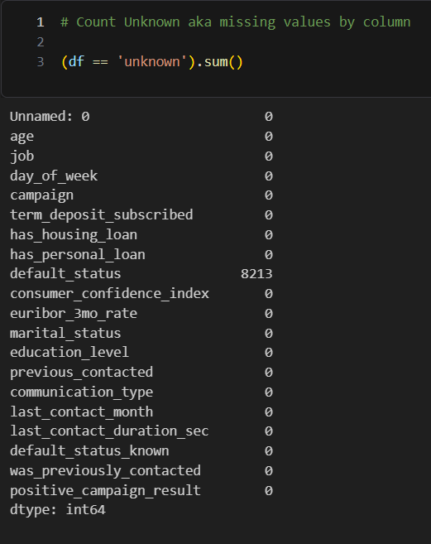

Heatmap for Correlation by column:
We can see that some columns are highly correlated, indicating that the information they provide overlaps significantly. Dropping all but one will help declutter the data, allowing our ML model to better grasp the underlying signal, improve predictability, and provide a more honest scoring metric.
As you can see in the missingness list above, I have chosen to drop 3/4 of the highly correlated columns, keeping only Euribor_3mo_rate.

euribor_3mo_rate : num_employees - 95% correlation
euribor_3mo_rate : employment_variation_rate – 97% correlation
consumer_price_index : employment_variation_rate – 78% correlation
employment_variation_rate : num_employees - 91% correlation

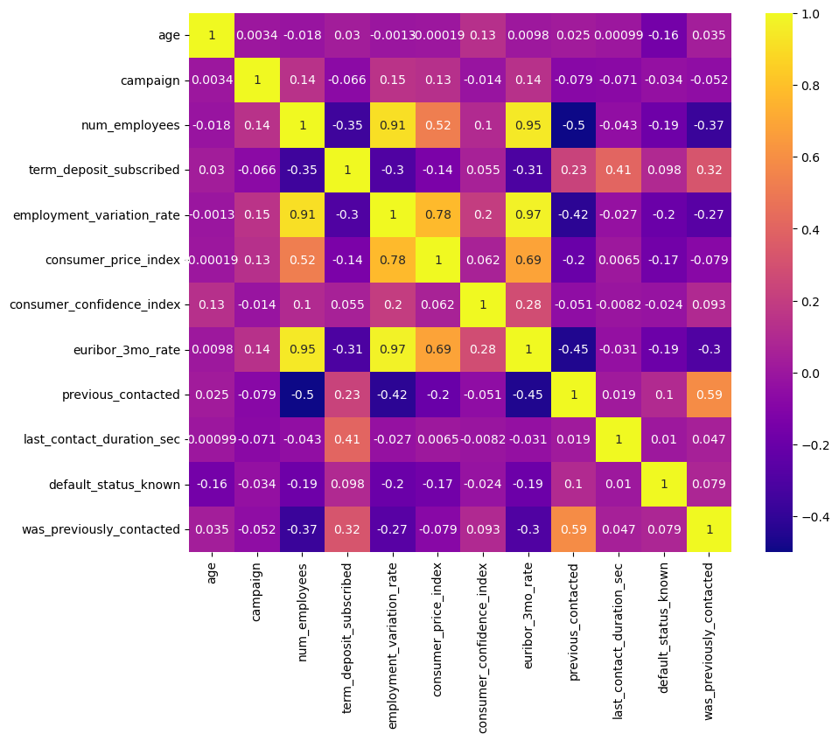

Age Distribution of all Customers:
The age distribution of the top 40 age groups across all customers shows that most customers fall into the 29-40 age group.
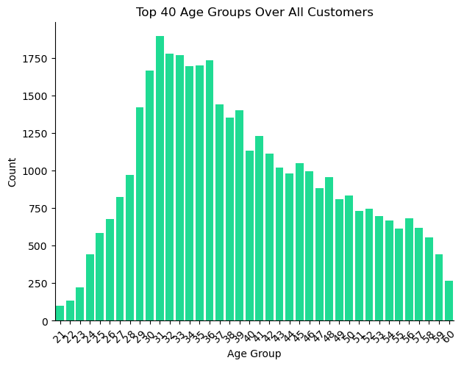
Top Subscribers Age Groups:
The goal of the bank's marketing team is to maximize the number of customers that subscribe to the term deposit program. As shown in the age distribution of term deposit customers, our top age groups are highly correlated with the overall age distribution.
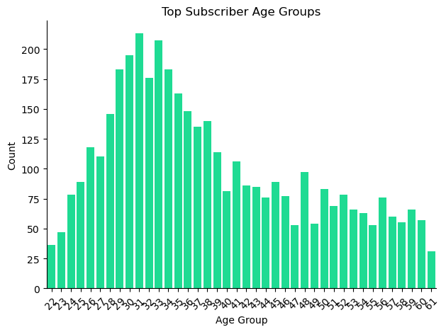

Previous Contact Rates of Subscribers vs Non-Subscribers:
The data below shows that subscribers to the term deposit program were contacted more than 2x as frequently as non-subscribers.
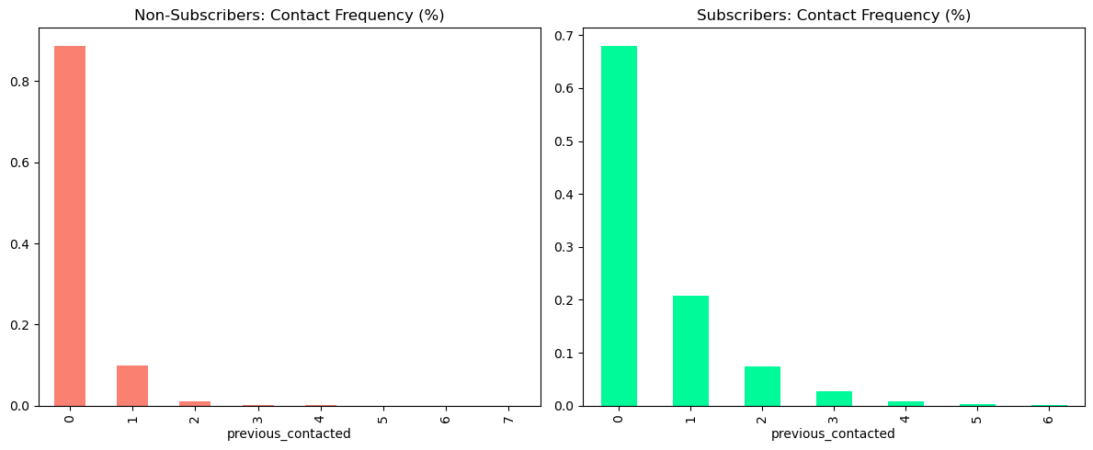

Mean Contact Rate of Subscribers:
This perspective shows the definite mean rate of contact between the bank and customers who subscribed to the term deposit program. The data shows that, on average, customers who subscribed were contacted nearly 4 times as often as those who didn’t.

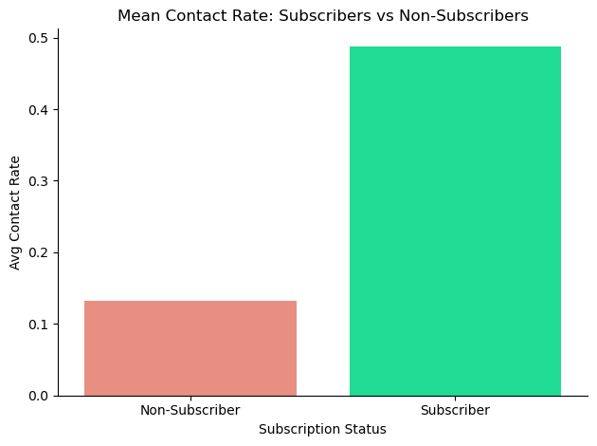

Overall Call Length Distribution in Seconds:
The data shows that, on average, most calls lasted between 0 and 1000 seconds, or just under 2 minutes.

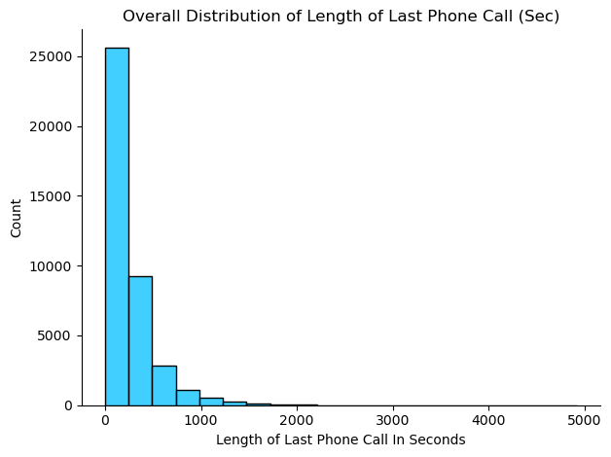

Average Call length of Term Dep. Subscribers:
We can see from the data that, on average, customers who did subscribe had phone calls that lasted 500 seconds, or just over 8 minutes.

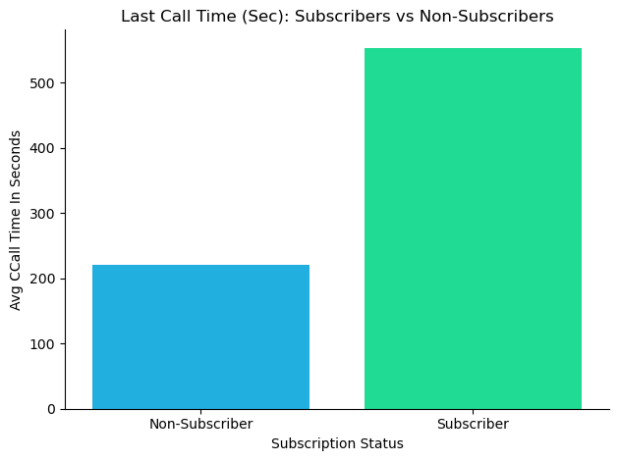

Contact Rates of Subscribers:
Here, we can see that customers who did subscribe were contacted at far lower rates than those who did not, nearly 6x less overall.

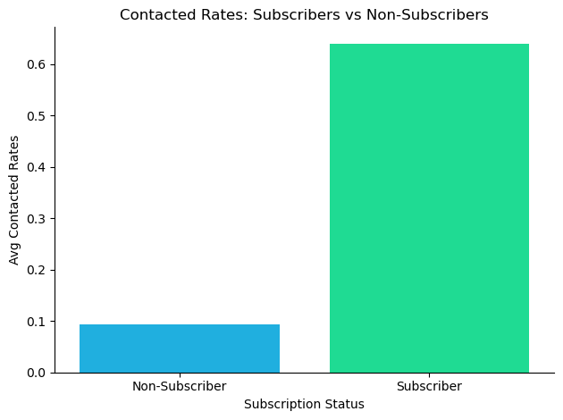

Contact Rate by Month:
The data shows contact rates peaking between April and May, then tapering off throughout the year, likely because the campaign to increase subscribers started in April.
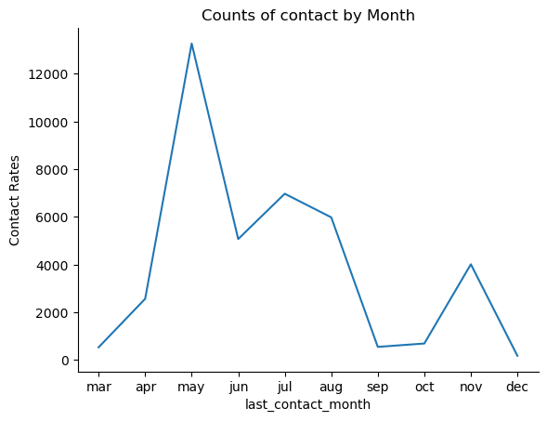

Overall Distribution of Customer Jobs:
From the data, we can see that the top three jobs our customers work in are Admin, blue-collar, and technician.
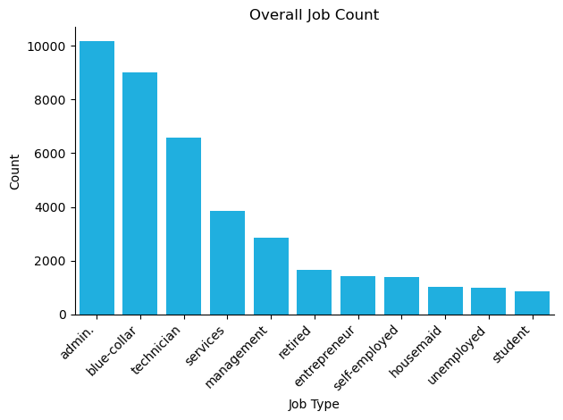

Term Deposit Subscribers by Job Type:
As we can see, the distributions are similar, except that retirees and students make up a larger share of subscribers than their frequency in the overall distribution would suggest.

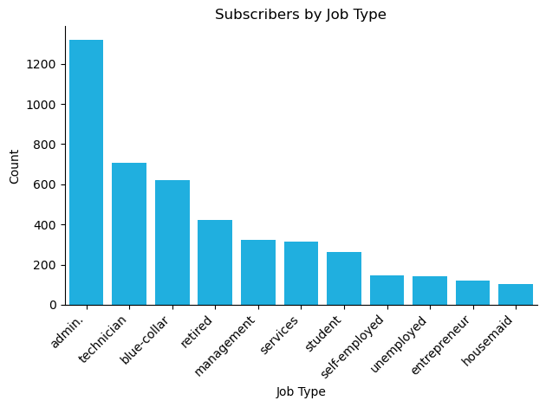

Non Term Dep. Subscribers by Job Type:
Conversely, the job distribution of non-subscribers shows that the top three remain the same, as expected, since they account for a large share of the overall frequency. Many more students subscribe to the program than not.
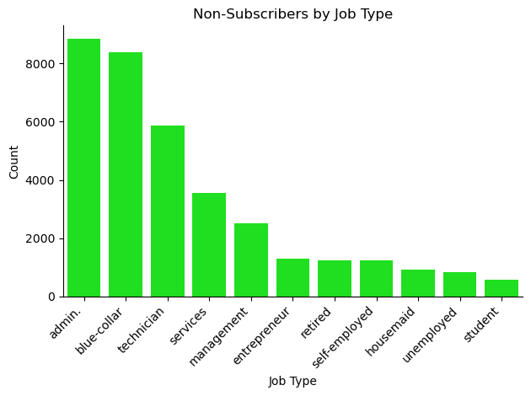

Overall Education Type Distribution:
Overall, most customers have at least a high school diploma or a four-year university degree.
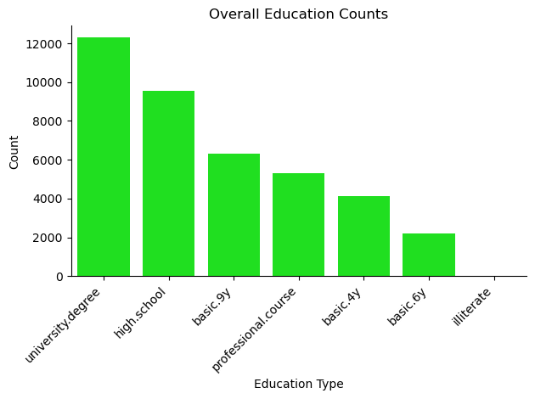

Job Types by Education Level:
Here, the job type roughly correlates with the education level required for that role.

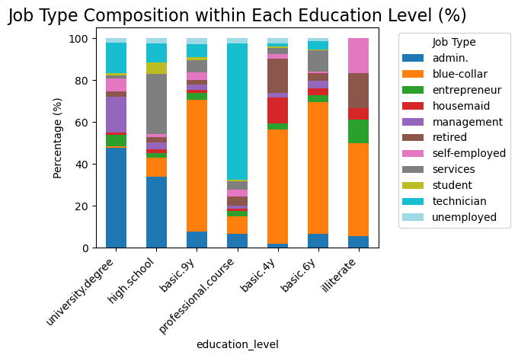

Term Deposit Subscribers by Education Level:
The data shows a strong correlation between higher education and propensity to subscribe to the term deposit program.
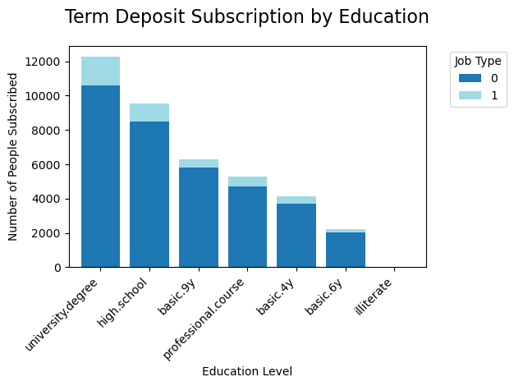

One key business research question
How can we improve our targeted marketing to increase subscription rates for the new Term Deposit Program?
My goal as a marketing analyst for the bank is to thoroughly understand the underlying groups within our customer base so we can build better relationships through marketing, products, services, promotions, and particularly to grow the Term Deposit Program.
While we can understand our customers well overall through a general exploratory analysis, deeper insight will be achieved from a machine learning approach using a clustering algorithm.
Once we have successfully segmented our customers using a clustering algorithm, we can derive meaningful statistical insights from the characteristics of the resulting clusters.

At least three sub-questions
Who are the key customer groups that exist within the data? How many unique customer groups exist?

- What are the distributions of demographic characteristics like education, age, job, etc., that exist within each cluster?
- Do any clusters show a greater propensity for taking home/personal loans?
- Are there clusters that have higher rates of default on loans than others?
- Which clusters, if any, have the highest rates of joining the Term Deposit program?

Your approach to data preparation
Looking at the data so far, a few preparatory steps should be taken to make the general analysis easier and ensure the clustering process works properly.
- First, the column names are not very descriptive. I will rename most of the columns to better reflect the data they contain.
- About 20.6% of the default status column contains missing data in the form of a value labeled ‘unknown.’ This is likely because the customer never had, or at least doesn’t currently have, a loan with the bank, which is worth preserving. To preserve this information, I will one-hot encode this column so that each value (‘yes’, ‘no’, or ‘unknown’) becomes its own column, with each row's values becoming binary to indicate whether the value applies.
- The columns ‘job’ and ‘marital_status’ each have 0.8% and 0.2% missing values, respectively, so I will drop these values as they are unlikely to affect the data.
- The ‘education_level’ column has 4.2% unknown values, so I will impute these values with the mode of the column so that I don’t lose these rows.
- The ‘has_personal_loan’ and ‘has_home_loan’ columns had about 98.4% overlap where the values were unknown, since this only accounts for about 2.5% of the total data. I dropped the rows where the overlap occurred, whereas I could have one-hot encoded, but I would be preserving much of the predictive signal by doing so.
- The columns ‘euribor_3mo_rate’, ‘employment_variation_rate’, ‘num_employees’, and ‘consumer_price_index’ are all highly correlated with each other, so I will drop three of them to avoid multicollinearity issues.

Looking at the column data types, 9/17 columns are categorical, meaning they will all need to be numerically encoded so the predictive signals they provide can be modeled more effectively by clustering and classification ML models I might use. Of the columns to be encoded, most will be one-hot encoded because each has multiple potential categories with no specific order.
One-Hot Encoded columns include:
job
day_of_week
campaign
marital_status
communication_type

Ordinal Encoded Columns:
education_level

- Ordinal encoding is similar to one-hot encoding, but instead of creating multiple columns out of one, it assumes a natural ranking of the categorical items and numerically encodes them according to their rank.

Label Encoded Columns:

term_deposit_subscribed
has_housing_loan
has_personal_loan
default_status

- Label encoding assumes that the categorical values are binary in nature, often yes/no, and encodes those values with 1 or 0.

Data quality and potential external data sources for your analysis
I don’t expect any data quality issues. This data is already well-structured and has few missing values, so it doesn't require dropping large amounts of data. Additionally, much of the data is categorical, and handling this through encoding is a common ML practice that is fairly easy to implement.
Moreover, although the Bank-Marketing dataset should already be well-suited to ML tasks like clustering to understand customer groups, to improve marketing, and classification to predict those likely to join the term deposit program.
The UCI webpage states that the data itself comes from a Portuguese bank, so if I need to supplement the data, I may be able to find some demographic data from that country to add. However, it does not specify which bank the data is from or its location in the country, which would be important for data supplementation.

Your thoughts on the value that evidence-based decision-making can bring to addressing the problems represented in the dataset.

As I determined in last week's assignment, a general exploratory analysis can be very useful for understanding your core customer base and improving marketing efforts.
This analysis shows that the real value of evidence-based approaches to decision making is that they can shift marketing decisions away from assumptions and intuition toward patterns actually present in the data.
For example, rather than broadly targeting all customers with the same term deposit campaign, the EDA revealed that retirees and students subscribe at disproportionately higher rates than their share of the overall customer base, and that customers who ultimately subscribe have notably longer call durations and higher contact frequencies.
These conclusions would not be immediately obvious, and acting on them would allow the marketing team to allocate resources more precisely, prioritizing higher-value interactions over high-volume outreach.
The same logic applies to loan products for certain demographic or behavioral profiles that correlate with higher default rates or lower acceptance rates; a data-driven strategy can adjust messaging and timing of eligibility criteria accordingly.
In short, evidence-based decision-making converts raw customer data into a competitive advantage by grounding strategy in what customers actually do rather than what we assume they might.
The EDA has established a strong foundation, but it is limited to describing what exists in simple aggregations. The next phase will move from description to discovery, using the clustering and classification methods outlined above to uncover distinct customer segments within those overall distributions and, ultimately, to predict which customers are most likely to respond positively to future campaigns.
This will allow the evidence-based approach to scale from simple insights to deeper discoveries and predictions.

Explore different analysis techniques and decide on the techniques that you will use.

In this extended exploratory analysis phase, we moved beyond basic summary statistics and univariate visualizations to apply more sophisticated techniques. These methods were designed to uncover lighting structures, quantify relationships across mixed variable types (demographic, behavioral, and campaign-related), diagnose data properties critical for clustering, and generate marketing actionable insights before proceeding to agglomerative clustering for customer segmentation.

Broad approaches:
- Multivariate relationship exploration
- Lift analysis for categorical drivers of growth
- Distribution diagnostics and outlier assessment

Specific Techniques:
- Grouped Bar Chart Aggregations: Calculation of subscription rates by education level, home loans by education level, followed by the lift ratios of subscription rates by job type relative to the overall baseline subscription rate. Additionally, I filtered groups with fewer than 50 observations to ensure statistical reliability.
- Bar Charts With Baseline Reference Line: Visual comparison of lift values across education categories, with a reference line at the overall mean subscription rate.
- Univariate Ratio Analysis In Bar Charts: Looked at single variable distributions again, but from the perspective of each category's percentage of total vs simple frequency count.
- Distribution Analysis in Violin Plots: Used violin plots to compare the means of two variables and their overall dispersion.

Your rationale for using those techniques

These techniques were chosen because the dataset contains a mix of categorical (education_level, job, marital_status, etc.) and numerical/behavioral features (age, campaign, last_contact_duration_sec, Euribor_3mo_rate, consumer_confidence_index) with a binary target (term_deposit_subscribed)

- Lift analysis + Grouped Aggregations: Quantify how strongly individual categorical levels (especially job and education) drive the target outcome beyond the baseline. This directly highlights segments with disproportionate subscription propensity. It also supports marketing campaign design and provides clear, interpretable business metrics.
- Bar Charts with Baseline Overlay: Make the lift results immediately visual and stakeholder-friendly, allowing quick identification of high-lift vs. low-lift groups while also avoiding over-interpretation of small-sample categories (addressed via the min_count filter). Additionally, I can use bar charts to show the percentage of overall subscribers that come from each category of a specific variable.
- Distribution Analysis: Shows the distribution of the target variable relative to other categories such as age, rates of previous contact, length of most recent contact, etc.

Potential assumptions, considerations, and challenges to the data, analysis, results, and presentation

Assumptions:
- The observed lift in subscription rates by education level reflects genuine behavioral differences rather than being caused by confounding factors like a strong correlation.
- Groups with over 50 observations will provide a sufficiently stable estimate of that group's rate relative to the target variable, and smaller groups can be appropriately excluded to avoid volatile lift values.
- ‘Unknown’ entries in the default_status category represent missing data, not a unique category, and can be replaced with NA.
Considerations:
- Age frequency analysis and other similar distribution analyses assume that the distribution is representative of the broader customer population; additional validation may be needed to verify the generalizability of findings.
- Lift is relative to the overall average, so interpretation must account for the fact that the overall mean subscription rate is relatively low.

Challenges:
- Data: Presence of unknown values and potential class imbalance in multiple categories, possible multicollinearity in economic indicators.
- Analysis: Lift can over-emphasize rare categories if filtering is too lenient.
- Results: We must ensure the integrity of lift results by comparing them to other multivariate analyses and clustering results.
- Presentation: Visualizations must remain clear and interpretable for non-technical audiences.

Your approach to Exploratory Data Analysis

- Load the cleaned dataset and recheck overall data quality.
- Convert object data type columns to category data type for efficiency.
- Compute the overall subscription rate as a baseline.
- Apply group by aggregations to calculate category-specific subscription rates and lift ratios.
- Filter low-count groups and generate a sorted bar chart with baseline reference.
- Explore category distributions relative to their subscription rate to understand subscription demographics better.
- Document all outputs (tables and plots) with clear titles and labels for the report and presentation.

The insights obtained from Exploratory Data Analysis

The overall subscription rate chart establishes the baseline for all lift calculations. With only 11% of customers subscribing to a term deposit (class ‘1’), the dataset shows significant class imbalance. Because lift is calculated as a ratio (segment rate / overall rate), even small absolute changes in overall subscription rates can cause large proportional shifts in lift values. Any model or targeting strategy must therefore account for this sensitivity and class imbalance.
In this case, accounting for class imbalance and lift sensitivity means designing models and targeting approaches that remain effective despite this. This includes using techniques such as class weights, resampling during training, and evaluating using precision/recall rather than accuracy metrics.
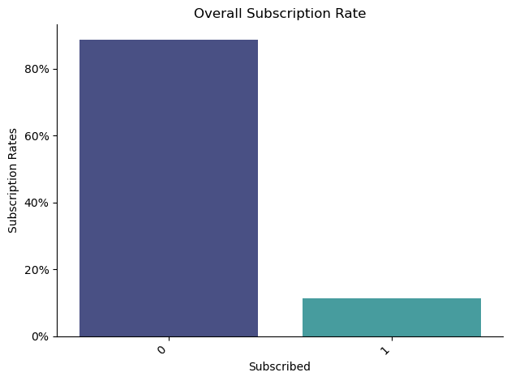

This box plot compares the distribution of the 3-month Euribor interest rate between non-subscribers (0) and subscribers (1). Non-subscribers are concentrated at higher Euribor levels (around 4-5%), while subscribers show a bimodal distribution, largely concentrated around the 1% rate. This suggests that customers are more likely to subscribe during periods of lower interest rates, reflecting a greater openness to locking in a fixed-rate deposit when market rates are falling.

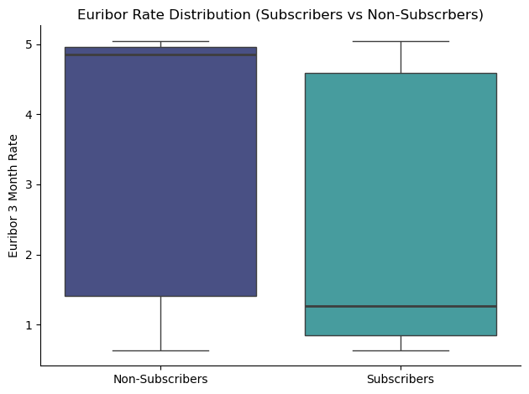

This bar chart shows that the subscription rate substantially varies by education level. Customers with a university degree subscribe at approximately 30%, more than double the rate of those with only a four- to nine-year education. This gradient indicates that education is a meaningful predictor of term deposit subscription, likely reflecting differences in financial literacy, disposable income, and investment orientation.
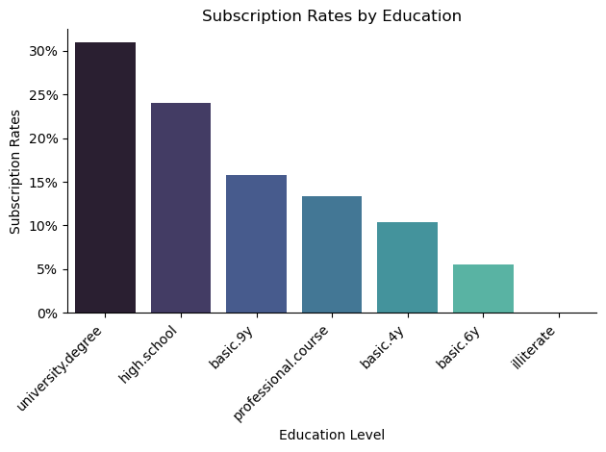

Subscription rates also differ considerably by job type. Administrative and blue-collar workers lead in raw subscription rates, but when adjusted for group size, students and retired individuals subscribe at comparatively higher rates. This may suggest that life stage and income stability, rather than occupation alone, can drive subscription.
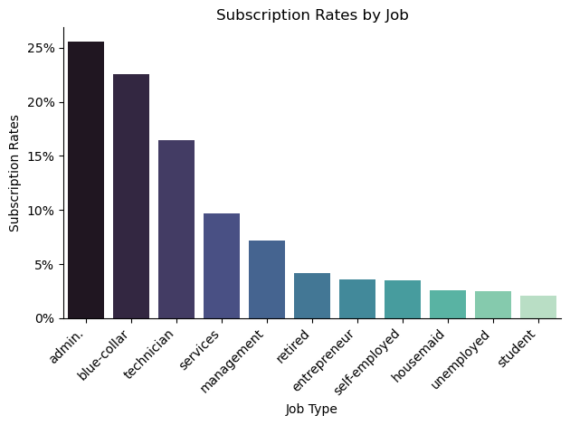

Customers contacted via cell phone subscribed at roughly 65%, compared to approximately 36% for those reached by landline. This gap may reflect differences in demographic profiles or simply greater engagement and availability among mobile customers.

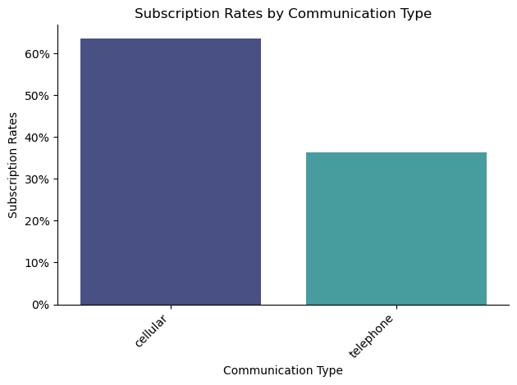

Subscription rates are relatively stable across weekdays, ranging from approximately 19% to 21%, with Monday and Thursday performing slightly better than the other days.
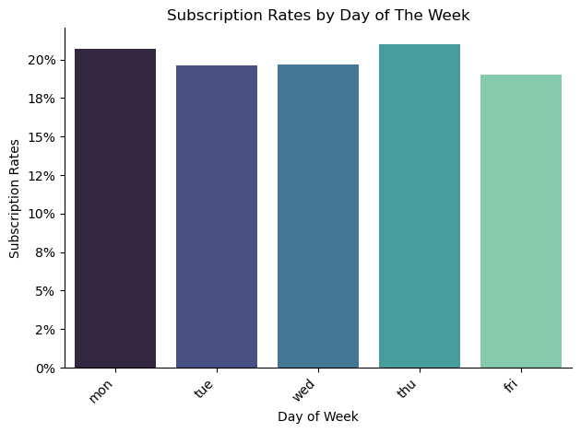

The last month of contact shows a pronounced effect on subscription rates. May dominates in terms of volume and achieves the highest subscription rate at about 35%, followed by July and August. This may reflect A seasonal pattern or simply a result of campaign efforts that wane throughout the year.
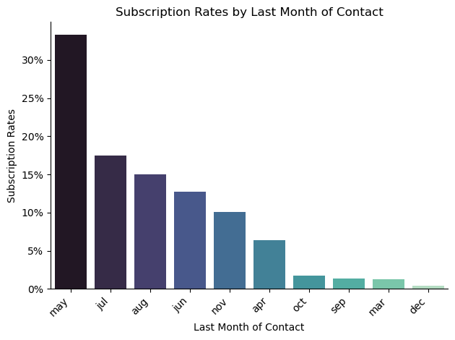

Age distributions are broadly similar between subscribers and non-subscribers, with both groups centered around the mid-30s to mid-40s. However, subscribers show a slightly wider spread, extending into older age ranges, consistent with higher subscription rates among retirees.
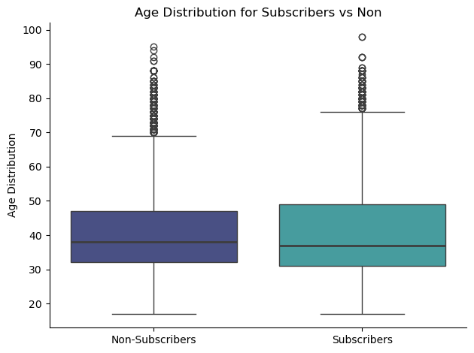
Last contact duration is one of the strongest behavioral signals in the data set. Subscribers show a dramatically longer median contact duration and wider distribution skewed towards higher values, while non-subscribers are tightly clustered near 0. Longer calls indicate higher engagement and likely reflect genuine interest during the conversation. This is likely to be an important feature for clustering and other predictive models.

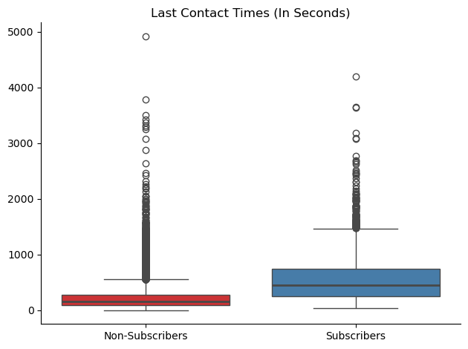

The number of previous campaign contacts differs sharply between groups. Non-subscribers have a median of zero previous contacts, indicating that most were contacted for the first time. Subscribers, by contrast, show a distribution of prior contacts ranging from 1 to 3, suggesting that re-engagement strategies targeting customers with prior campaign history may yield higher conversion rates.

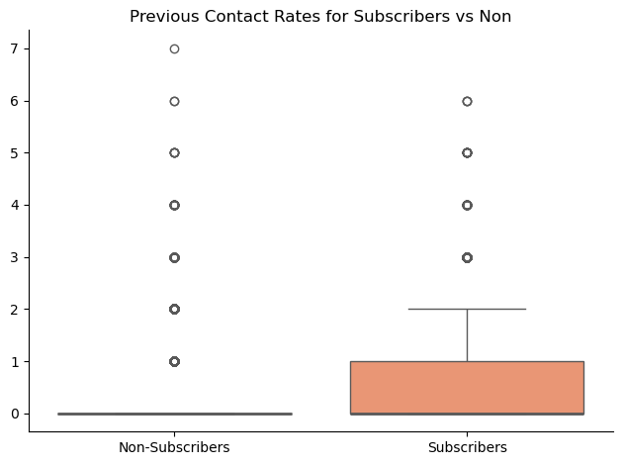

The lift chart by job category quantifies each group's performance relative to the overall subscription baseline. Students and retired individuals show the highest lift (2.5x and 2.2x, respectively), indicating these groups subscribe at more than double the average rate. at around 0.6x. These results inform which job segments should receive elevated priority in future campaigns.
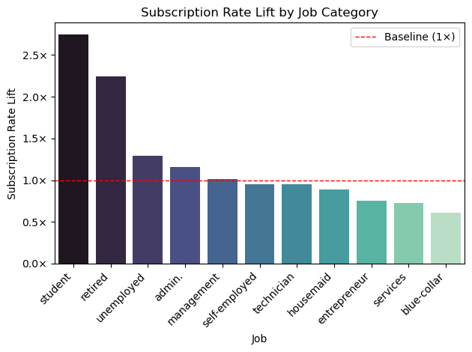

The education lift chart confirms that university degree holders subscribe at approximately 1.2x the overall average, while customers with only basic schooling (6 or 9 years) fall to around 0.65-0.75x baseline. High school and professional course completers perform near the average.
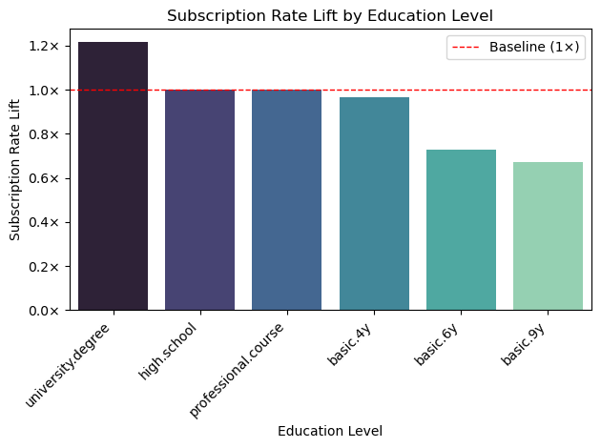

Your approach to analytics modeling (supervised learning, unsupervised learning, time series, etc. )
My primary approach to analytics modeling for my UCI Bank Marketing dataset is clustering, an unsupervised learning method. From a marketing analytics perspective, my goal is to understand the customer base better and identify which demographic and behavioral characteristics are most strongly associated with term deposit subscriptions. This framing guided the selection and testing of multiple clustering algorithms.
K-Means was the first algorithm tested, run across varying numbers of clusters, but the resulting segments consistently showed significant overlap as measured by Silhouette Score. TO address this, Principal Component Analysis (PCA) was applied as a preprocessing step. PCA reduces dimensionality by constructing a linear combination of the original features that captures the maximum variance, thereby reducing noise and improving cluster separation. While PCA improved the Silhouette Scores somewhat, the clusters remained insufficiently distinct to serve as a reliable basis for segmentation.
Since the primary objective of clustering is to define clearly distinguishable customer subsets, Agglomerative Clustering was evaluated as an alternative. This algorithm has a higher chance of success because it is well-suited to hyperparameter tuning, allowing systematic variation of both the linkage (distance) metric and the number of clusters. Using the same PCA-reduced feature set as in the K-Means experiments, Agglomerative Clustering was run across three linkage methods (ward, complete, and average) and cluster counts from 2 to 7, with the Silhouette Score also used as the performance criterion.

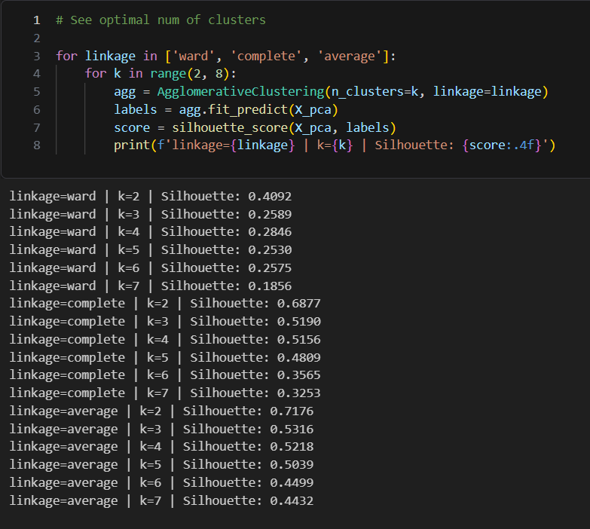

This approach produced substantially better cluster separation. The ‘average’ linkage with k=2 achieved the highest Silhouette score of 0.7176, and ‘complete’ linkage with k=2 scored 0.66877. However, both configurations produced highly skewed cluster-size distributions, with one cluster containing the vast majority of customers and the other two containing only a small fraction, if any.
Ultimately, the ‘ward’ linkage with k=3 was selected, achieving a Silhouette score of 0.2589. While lower in absolute terms than the highly skewed configurations, this setting produced three meaningfully sized and interpretable customer groups with the most balanced distribution of observations across clusters, making it the most actionable choice for marketing segmentation.

The analytics results obtained from analytics modeling

The first analysis examined job distributions across clusters. The top four occupations: admin, blue-collar, technician, and services appeared in all three clusters in roughly similar proportions. One notable difference was Cluster 1, where the blue-collar count approached the admin count nearly equally, a pattern not observed in Clusters 0 or 2, where admin led more clearly.
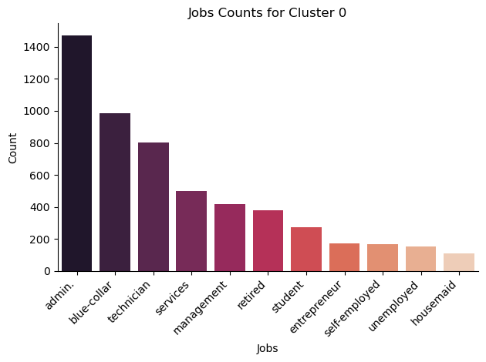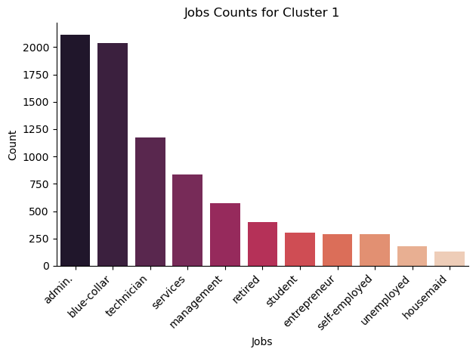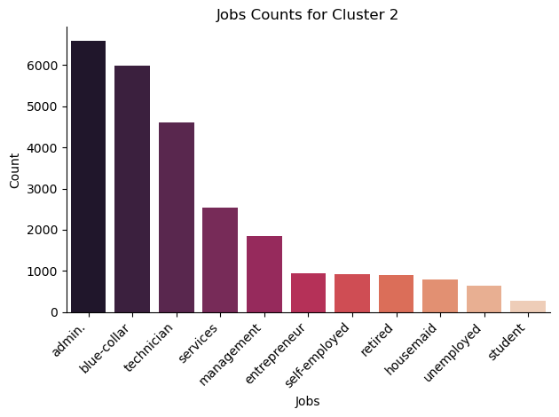

Age distributions were largely consistent across all three clusters, with median ages falling in the 35-40 range. Cluster 1 was slightly younger, but the difference is not substantial enough to constitute a meaningfully distinct demographic profile based on age alone.
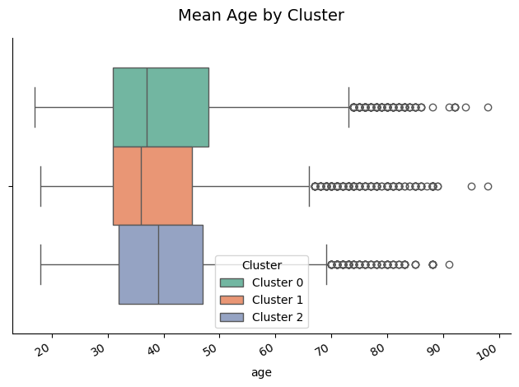

The heatmap of mean numeric features by cluster reveals several key differentiators at a glance. Cluster 1 has the highest term deposit subscription rate at 37%, compared to 26% for Cluster 0 and 0% for Cluster 2. The most striking feature of Cluster 2 is its mean Euribor 3-month rate of approximately 4.63%, compared to 1.5% and 1.83% for Clusters 0 and 1, respectively. This near-3-point difference in the interbank lending rate reflects substantial differences in macroeconomic environments, where one group has a fixed-rate term deposit that would generally be far less attractive.
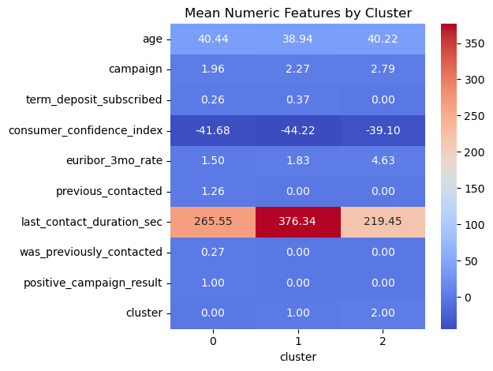

The bar chart of term deposit subscription rates by cluster reinforces the heatmap findings: Cluster 1 leads at approximately 37%, Cluster 0 follows at around 26%, and Cluster 2 records a subscription rate of effectively zero.

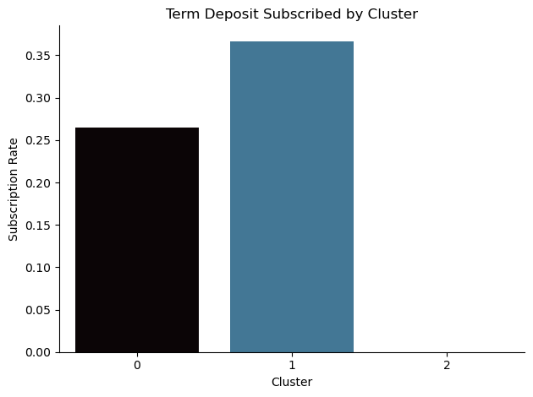

The median Euribor rate chart confirms that Clusters 0 and 1 experienced very similar rate environments, both just above 1%, while Cluster 2 was exposed to rates approaching 5%. This macroeconomic separation is likely a primary driver of the sharp divergence in subscription rates between Cluster 2 and the other two groups.
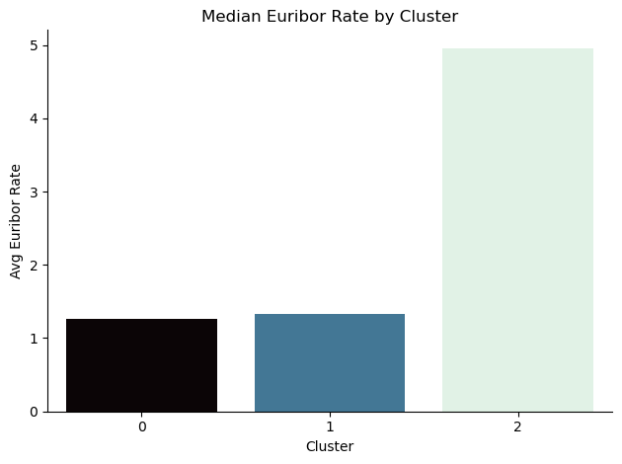

Median last contact duration follows the same pattern as subscription rates: Cluster 1 leads at approximately 250 seconds, followed by Cluster 0 at roughly 200 seconds and Cluster 2 at around 160 seconds. Longer contact durations are strongly associated with customer engagement, suggesting that the conversations leading to subscriptions in Clusters 0 and 1 were qualitatively different from those in Cluster 2.

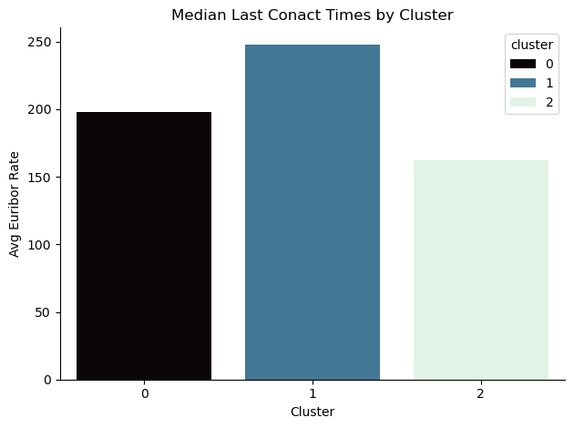

Across the Housing Loans, Personal Loans, and Default categories, no meaningful differences emerge between clusters. Each cluster mirrors the overall population distribution for these variables, with the majority of customers in all three clusters having no personal loan and no default record, and about half having a home loan.

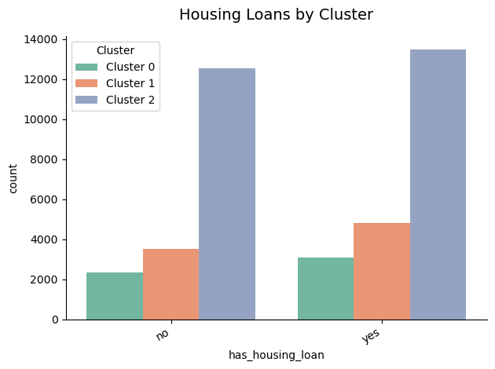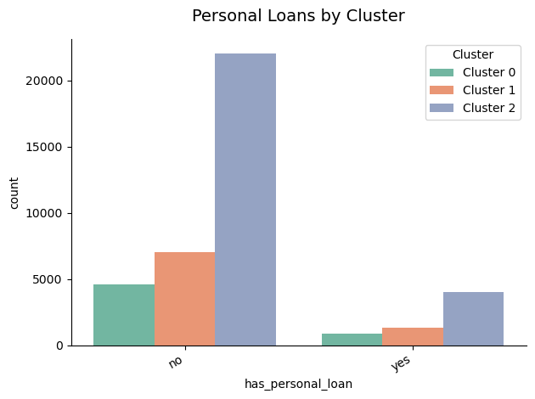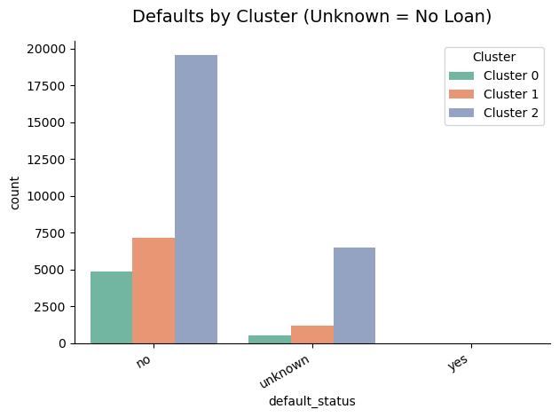

Communication type shows an important asymmetry worth noting. While cellular contact dominates in Clusters 0 and 1, Cluster 2 has a disproportionately high rate of telephone (landline) contact. As established in Week 3 EDA, cellular-contacted customers subscribed at nearly double the rate of landline-contacted customers. The prevalence of telephone contact in Cluster 2 is therefore consistent with, and likely a contributing factor to, that cluster's zero subscription rate.

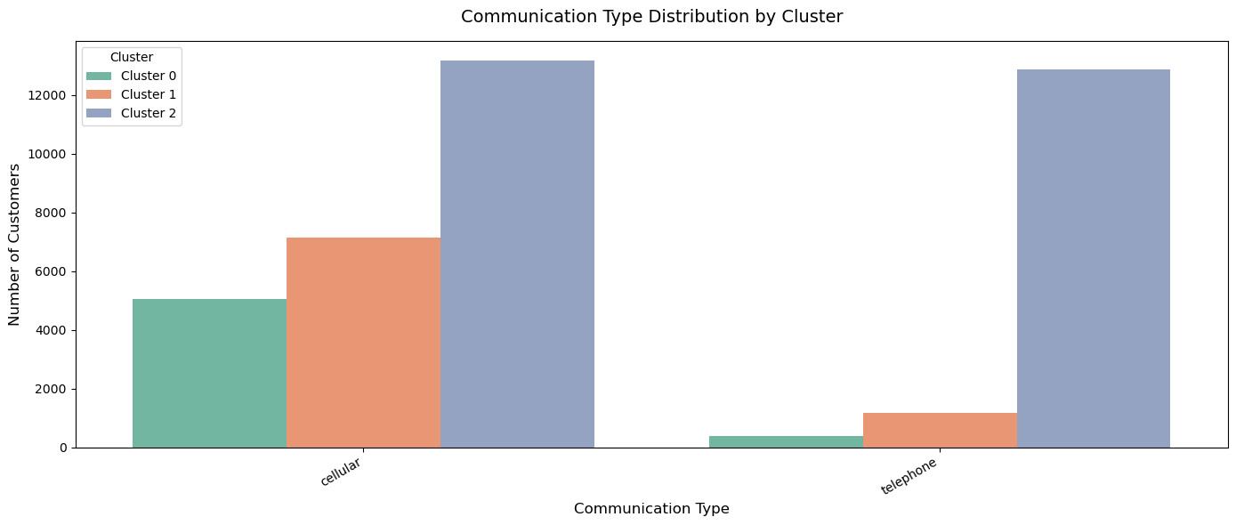

Marital status distributions across clusters largely mirror the overall population composition, with married customers comprising a large share in all three clusters. Clusters zero and one show a broadly balanced mix, with married and single customers closer to what is given, simply containing more of each category. No marital status group shows a meaningful differential subscription propensity within its segmentation.
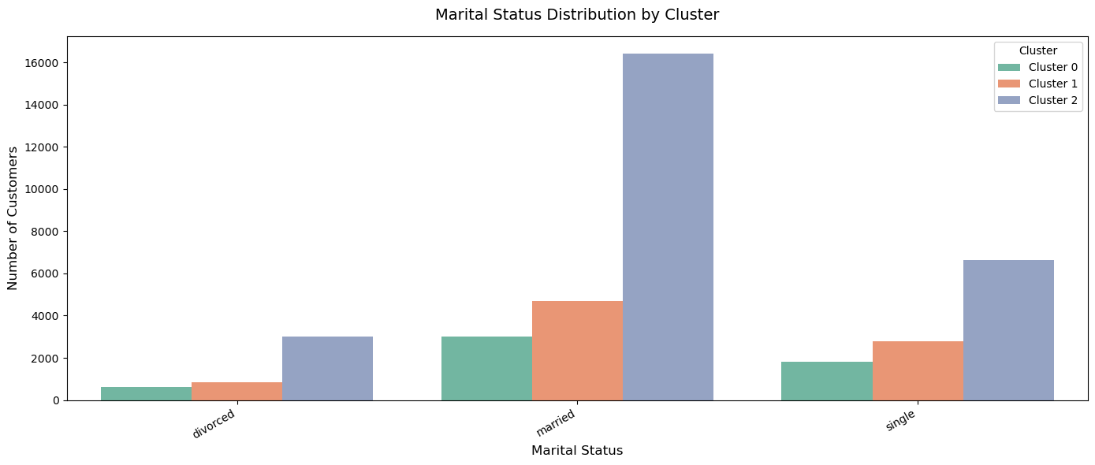

The education distribution confirms the week 3 EDA finding that higher education is positively associated with subscription likelihood. Among Clusters 0 and 1, customers with high school and university degrees represent the largest education segments, accounting for nearly all subscriptions. The pattern holds proportionally, even accounting for cluster two's larger overall size, reinforcing the meaningful segmentation characteristic of the education levels.
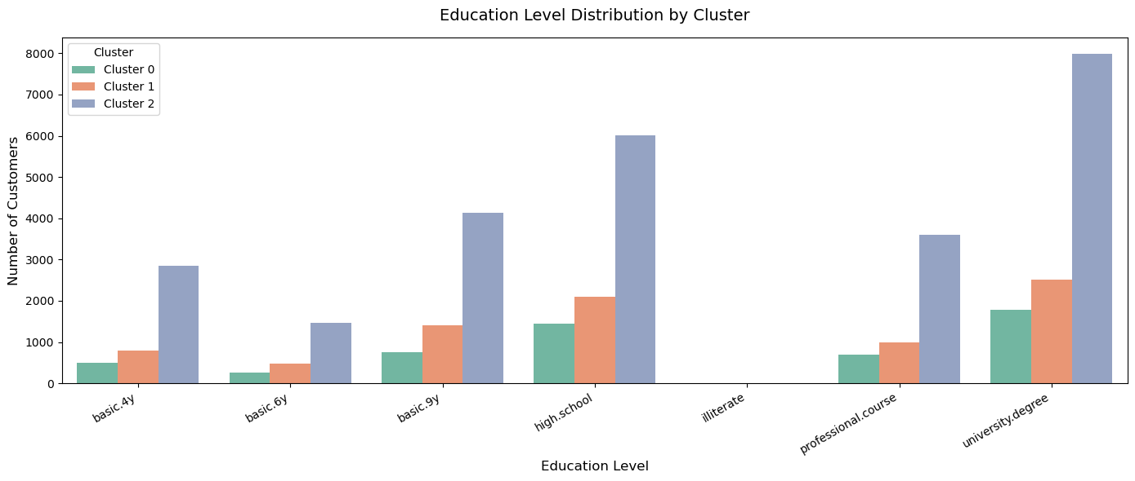

A notable finding is that cluster 2, which produced 0 subscriptions, was contacted more frequently than the other two clusters: approximately 25,000 contacts, compared with roughly 5,000 and 8,000, respectively.

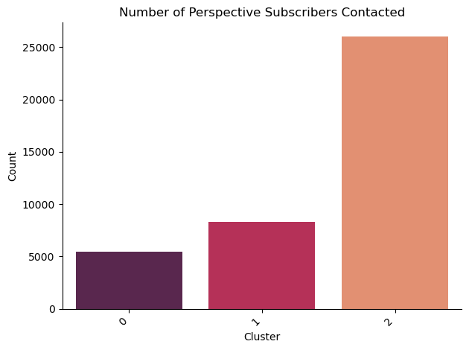

Answers to the research business question and the sub-questions

How many unique customer groups exist?
- 3 Unique customer groups exist, as determined by agglomerative clustering.

What are the distributions of demographic characteristics like education, age, job, etc., that exist within each cluster?
- Demographic profiles were broadly similar across all three clusters, with all groups centering on a median age of 35 to 40, similar marital status distributions in the same top 4 occupations (admin, blue-collar, technician, and services). The key demographic differentiator was education: Clusters 0 and 1, which contained all subscribers, skewed toward higher levels of education.

Do any clusters show a greater propensity for taking home/personal loans?
- Across all clusters, customers are roughly split between having and not having a housing room. This split is consistent across clusters, so housing loan status does not appear to differentiate subscription behavior.
- Similarly, most customers do not take personal loans.

Are there clusters that have higher rates of default on loans than others?
- There is no meaningful difference between clusters; there were actually so few overall that it doesn’t show up in the graph of defaults by cluster shown above.

Which clusters, if any, have the highest rates of joining the Term Deposit program?
- Clusters 0 and 1 have the highest rates of joining the term deposit program.
- A couple of things specifically stood out to explain their propensity to subscribe vs cluster 2, which didn’t subscribe at all:
  - Clusters 0 and 1 experienced a Euribor 3-month rate of approximately 1.2 to 1.8%, nearly 3.5 percentage points lower than cluster 2’s rate of approximately 4.63%. A lower Euribor rate reduces the opportunity cost of locking savings into a fixed rate of term deposit, making subscription a more financially rational decision for customers in those clusters.
  - Next, clusters 0 and 1 had mean last contact times that were 25% and 40% higher than those of cluster 2.
  - Cluster 2 also received the most campaign contacts by a wide margin of over 3x that of cluster 1. The complete absence of subscription in this cluster, despite the high contact volume, strongly suggested the macroeconomic conditions were the primary barrier, not insufficient outreach. This finding supports incorporating the Euribor rate thresholds as a future campaign criterion.

Summary

Analysis of the UCI Bank Marketing dataset reveals that macroeconomic conditions, customer demographics, and behavioral signals are the strongest predictors of the likelihood of subscribing to term deposits.
Economically, the Euribor Rate is the strongest differentiator; clusters contacted during low-rate environments (1.2% - 1.8%) drove all subscriptions. At the same time, the high-rate cluster (4.63%) recorded zero. This suggests that campaign timing should be tied to rate environments.
Demographically, the core customer base falls in the 29-40 age range, is employed in administrative, blue-collar, or technical roles, and holds at least a high school diploma. Despite their smaller share of the base, retirees and students subscribe at more than double the average rate, making them high-priority targets. University-educated customers also show a meaningful positive lift at 1.2x the baseline rate.
Behaviorally, subscribers were contacted nearly 4x as often as non-subscribers, with average call durations exceeding 8 minutes, which is roughly 50 seconds longer than non-converting contacts. Cellular outreach significantly outperformed landline contact, and customers with prior campaign history converted at higher rates, pointing to the value of re-engagement. Seasonal patterns also emerged, with April-May contacts achieving the highest subscription rates.
Together, these findings support a campaign strategy centered on low-rate timing windows, prioritizing educated and financially literate segments, especially retirees and students, through sustained, high-quality engagement rather than high-volume, short-duration outreach.

